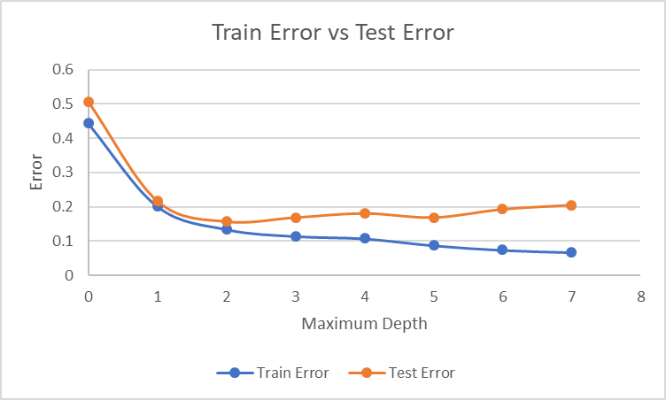[83democrat/66republican]

| Superfund_right_to_sue=y[28democrat/64republican]

|| Aid_to_nicaraguan_contras=n[13democrat/58republican]

||| Export_south_africa=y[13democrat/38republican]

||| Export_south_africa=n[0democrat/20republican]

|| Aid_to_nicaraguan_contras=y[15democrat/6republican]

||| Mx_missile=n[12democrat/0republican]

||| Mx_missile=y[3democrat/6republican]

| Superfund_right_to_sue=n[55democrat/2republican]

|| Export_south_africa=y[55democrat/1republican]

||| Immigration=y[9democrat/1republican]

||| Immigration=n[46democrat/0republican]

|| Export_south_africa=n[0democrat/1republican]